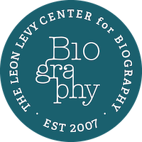

Press Release – April 24, 2025

Kai Bird, the Executive Director of the Leon Levy Center for Biography, announced today the award of six resident fellowships at the Graduate Center, including the seventh Leon Levy/Alfred P. Sloan fellow for a biography on a figure from science, and a Dissertation Fellow. Mr. Bird, a Pulitzer Prize-winning biographer, is most recently the author of The Outlier: The Unfinished Presidency of Jimmy Carter. Oppenheimer, the global blockbuster motion picture inspired by his biography of Robert Oppenheimer, American Prometheus, won seven Academy Awards, including the Best Picture. The Leon Levy Center for Biography is hosted by the Graduate Center at the City University of New York—and generously funded by the Leon Levy Foundation. Each resident fellow receives a $72,000 grant, research assistance, writing space and full access to research facilities.

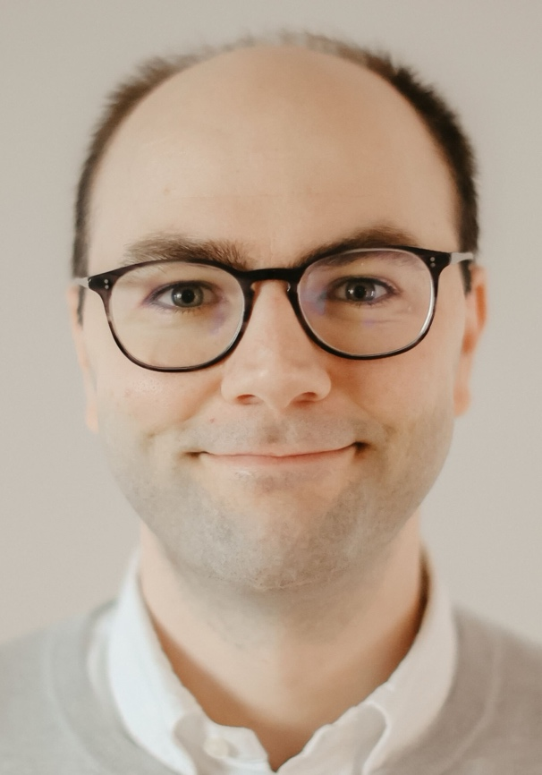

Levy/Sloan Fellow J. Arvid Ågren is a Research Associate in the Theory Division of the Lerner Research Institute at the Cleveland Clinic, and Affiliated Researcher at the Evolutionary Biology Centre at Uppsala University. His research focuses on the evolution of within-organism conflicts, including selfish genetic elements and cancers. He is the author of The Gene’s-Eye View of Evolution (2021, Oxford University Press), the first book-length treatment of the history of the selfish-gene theory. With Manus Patten, he is the editor of The Paradox of the Organism: Adaptation and Internal Conflict (forthcoming fall 2025, Harvard University Press). He is an Associate Editor of Proceedings of the Royal Society B and BioScience. He studied evolutionary biology at the universities of Edinburgh and Toronto, and was a postdoc at Cornell and Harvard. He is working on a scientific biography of Richard Dawkins.

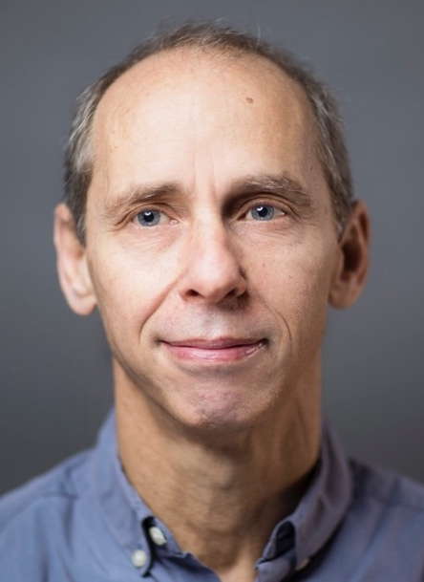

Peter Maass is the author of Love Thy Neighbor: A Story of War, which won the Los Angeles Times Book Prize for Current Interest, and the Overseas Press Club’s Cornelius Ryan Book Award. He is also the author of Crude World: The Violent Twilight of Oil, which was a finalist for the New York Public Library’s Helen Bernstein Book Award for Excellence in Journalism. He reported on the wars in Iraq and Afghanistan for The New York Times Magazine and The New Yorker, and won the Deadline Club Arts Reporting Award for a series of articles in The Intercept about the controversy over Peter Handke receiving the 2019 Nobel Prize for Literature. He will be working on a joint biography of Jacob Schiff and Felix Warburg – his great-great grandfather and great grandfather – in the context of their philanthropic support for Jewish immigration to British-controlled Palestine and their stance as non-Zionists opposed to the creation of a Jewish state there. His book will be published by Hachette’s Grand Central Publishing.

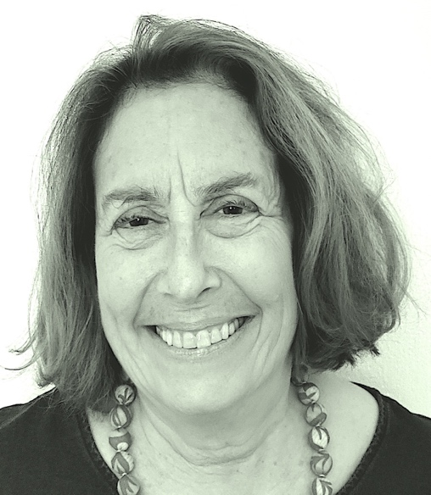

Deborah Solomon is an art critic, journalist and biographer. She writes frequently for the New York Times, and is currently at work on a full-scale biography of the artist Jasper Johns. Her books include Jackson Pollock: A Biography (1987); Utopia Parkway: The Life and Work of Joseph Cornell (1997); and American Mirror: The Life and Art of Norman Rockwell (2013).
In 2001, Solomon was awarded a grant from the John Simon Guggenheim Memorial Foundation in the field of biography. Her weekly interview column, “Questions For,” appeared in The New York Times Magazine from 2003 to 2011. She has served as an art critic for The Wall Street Journal and WNYC Public Radio.

.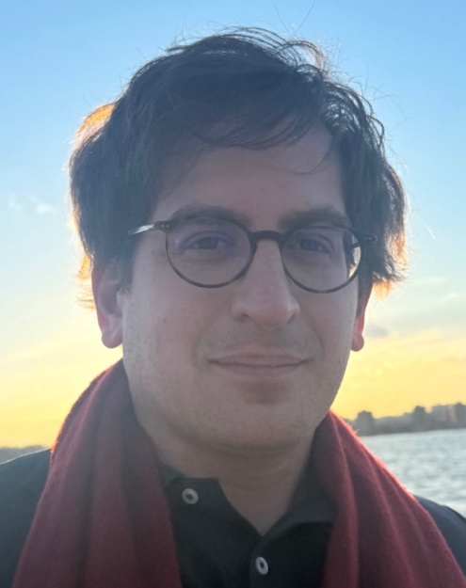

Alex Traub is a reporter on the Obituaries desk of The New York Times. Previously, he worked at two Indian papers, The Hindustan Times and The Telegraph of Kolkata, and at The New York Review of Books, where he was one of the last assistants of its editor and co-founder Robert Silvers. He is under contract with Farrar, Straus to write a book about Silvers focusing on his relationships with the leading writers and thinkers of his day and his impact on debates about the Vietnam War, Zionism, human rights, the politics of identity, the war on terror, and other major controversies in politics and culture.

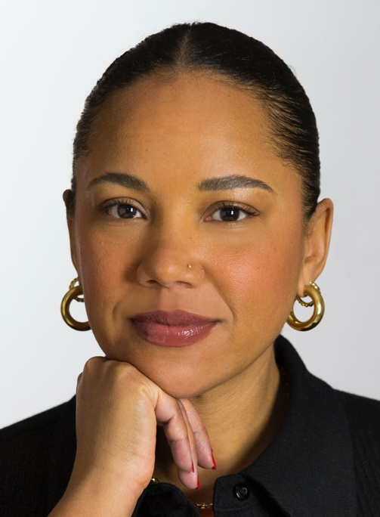

Autumn Womack is an Associate Professor of English and African American Studies at Princeton University. She is the author of The Matter of Black Living: The Aesthetic Experiment of Racial Data, 1880-1930 (The University of Chicago Press, 2022), which was awarded the Modern Language Association’s William Sanders Scarborough Prize and shortlisted for the Modernist Studies Association’s First Book Prize. She is also the editor of Norton Library’s edition of Charles Chesnutt’s 1901 novel The Marrow of Tradition (Norton, 2023). Her research and writing have been published in journals such as Black Camera: An International Film Journal, American Literary History, Women and Performance, J19: A Journal of 19th Century Americanists, The Paris Review of Books, The Los Angeles Review of Books, The Times Literary Supplement as well as numerous edited volumes. As a Leon Levy Fellow she will create an archival biography of Toni Morrison’s creative process.

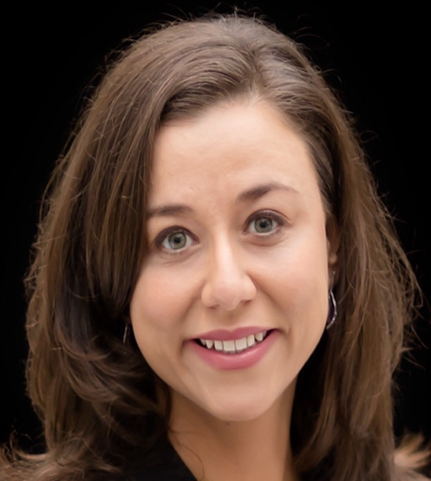

Dissertation Fellow Vanessa S. Troiano is a Ph.D. candidate in Art History at the CUNY Graduate Center. Her dissertation, “Susan Weil: Artistic Trailblazer,” is the first critical biography to survey the career of American artist Susan Weil (b. 1930). Vanessa earned a B.A. from Wellesley College and an M.A. with Distinction from the Courtauld Institute of Art in London. Her honors include a Women Writing Women’s Lives Kathy Chamberlain Award, a United States Teaching Assistantship with Fulbright Austria in Vienna, and a German Academic Exchange Service (DAAD) scholarship at the Goethe-Institut in Berlin. Vanessa’s writings have appeared in Routledge Research in Art History, Smarthistory, and Art History Teaching Resources. She has taught at Sotheby’s Institute of Art and CUNY’s Brooklyn, City, and Queensborough campuses.

